Create And Configure IBM Cloud Service Create Node-RED Service

|  |  |
| --- | --- |
| **Date** | **28 October 2022** |
| **Team ID** | PNT2022TMID40586 |
| **Project Name** | **loT Based Industry Specific Intelligent Fire Management System** |
| **Maximum Marks** | **4 Marks** |

# AIM

To Create Node-RED service.

# STEPS

1. Login to IBM Cloud with smart Internet mail ID and Password.

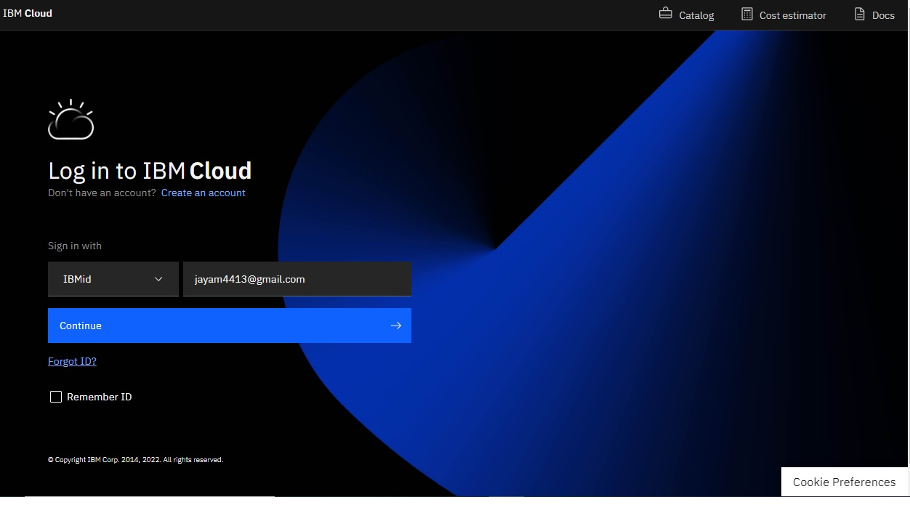

1. 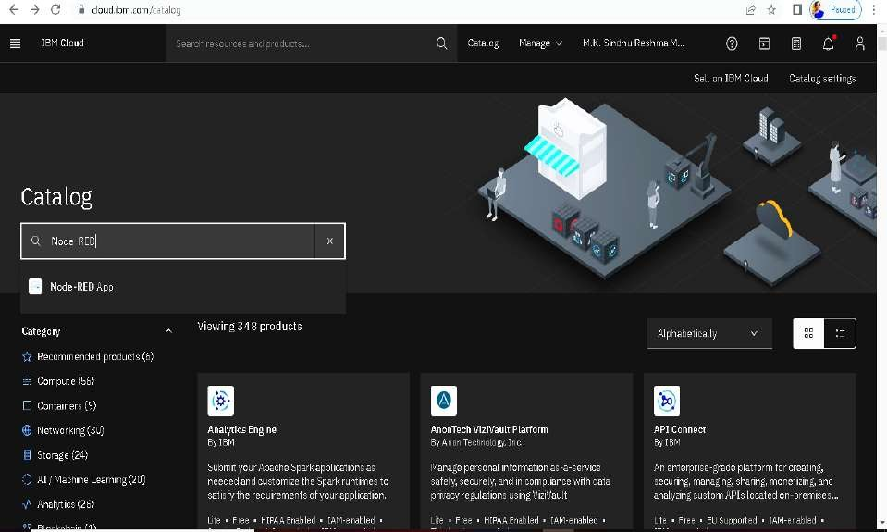Go to Catalog and Search for Node-red App in the search bar.
2. 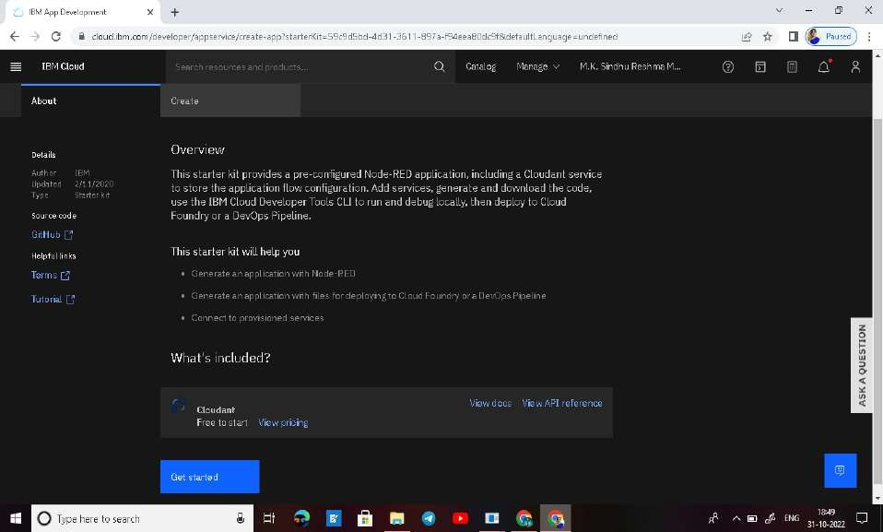Open Node-red App and click get start.
3. 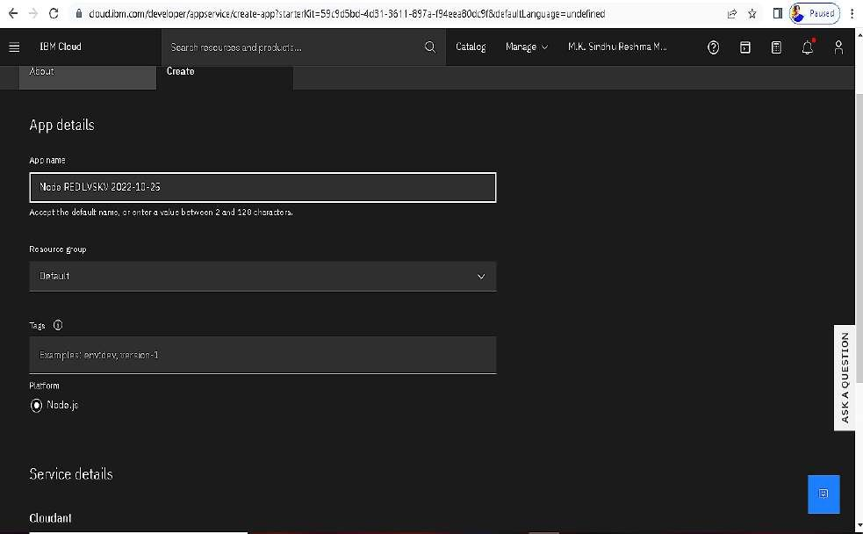In next page click create.

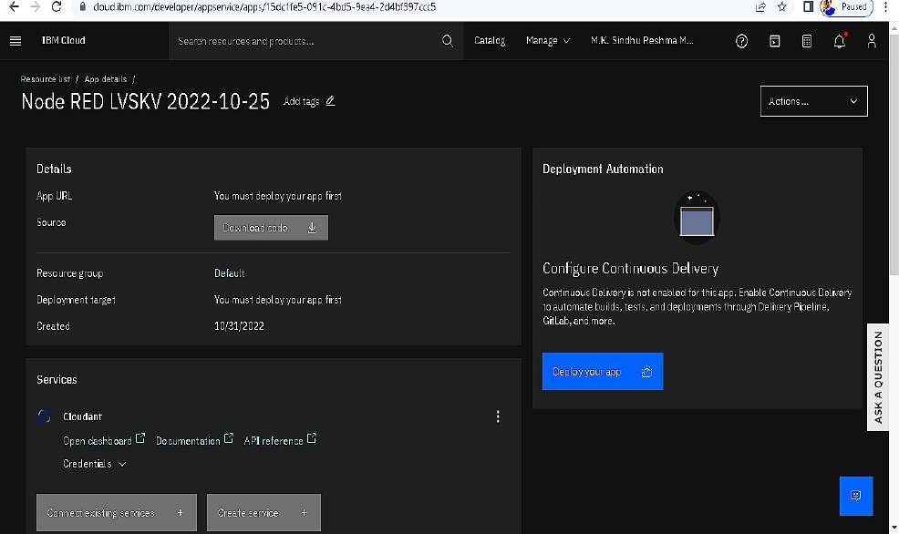

1. Click Deploy your app and it come to this page and select cloud foundry.

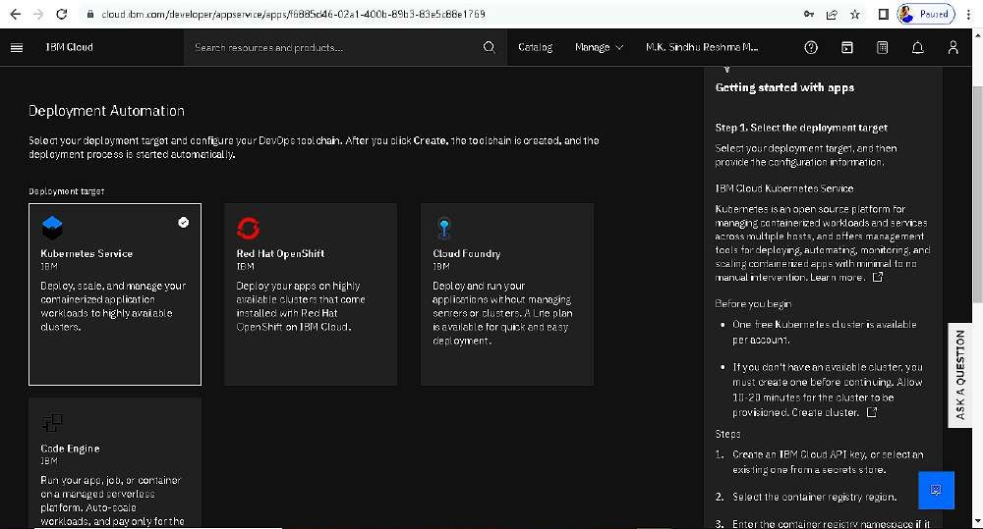

1. 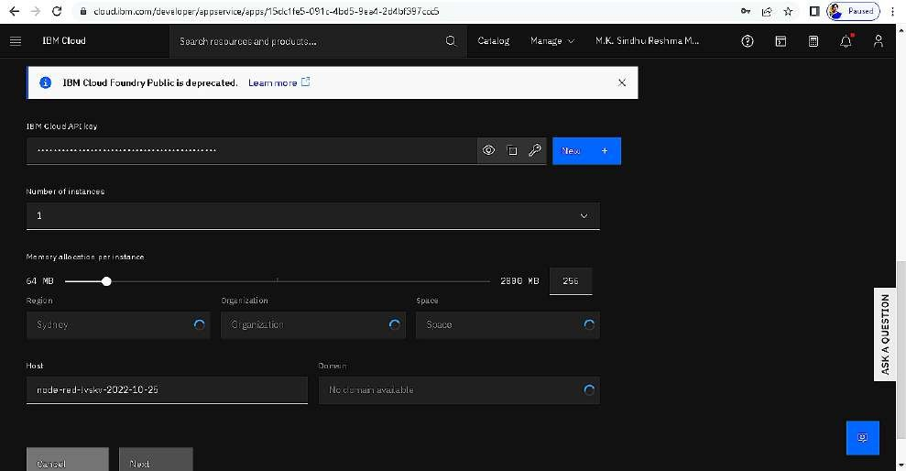Setting up the environment and deploying the app.
2. Successfully creating the app.

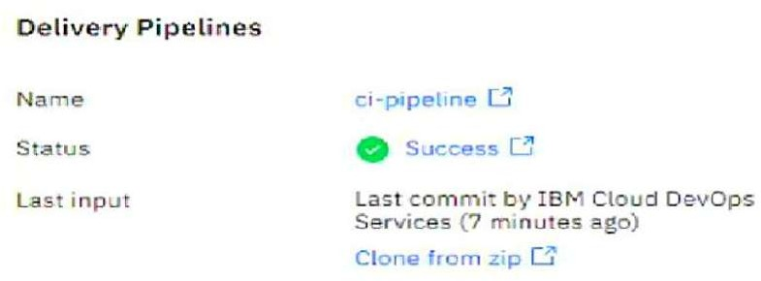

And it's work Successfully

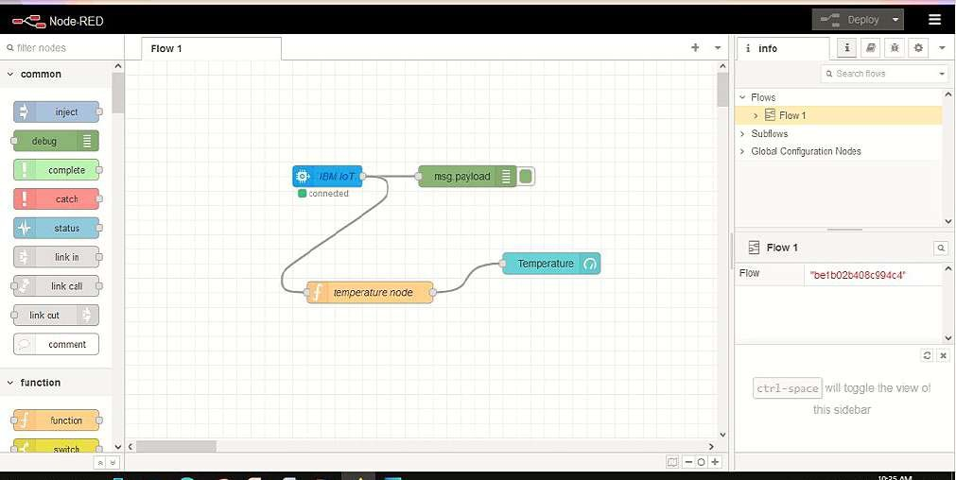

**RESULT**:

Successfully created the Node-RED service.

TEAM ID: PNT2022TMID40586

TEAM LEADER: C.V.GOWSIKHA MEMBER 1: K.TAMILARASAN MEMBER 2: G.ARULRAJ MEMBER 3: S.KUMARESAN

MENTOR: R.ARUL ARUMUGAM